**Course One**

# Foundations of Data Science



# Instructions

Use this PACE strategy document to record decisions and reflections as you work through this end-of-course project. You can use this document as a guide to consider your responses and reflections at different stages of the data analytical process. Additionally, the PACE strategy documents can be used as a resource when working on future projects.

# Course Project Recap

Regardless of which track you have chosen to complete, your goals for this project are:

* Complete the PACE Strategy Document to plan your project while considering your audience members, teammates, key milestones, and overall project goal.
* Create a project proposal for the data team.

# Relevant Interview Questions

Completing this end-of-course project will empower you to respond to the following interview topics:

* As a new member of a data analytics team, what steps could you take to get 'up to speed' with a current project? What steps would you take? Who would you like to meet with?
* How would you plan an analytics project?
* What steps would you take to translate a business question to an analytical solution?
* Why is actively managing data an important part of a data analytics team's responsibilities?
* What are some considerations you might need to be mindful of when reporting results?

**Reference Guide**

This project has three tasks; the following visual identifies how the stages of PACE are incorporated across those tasks.

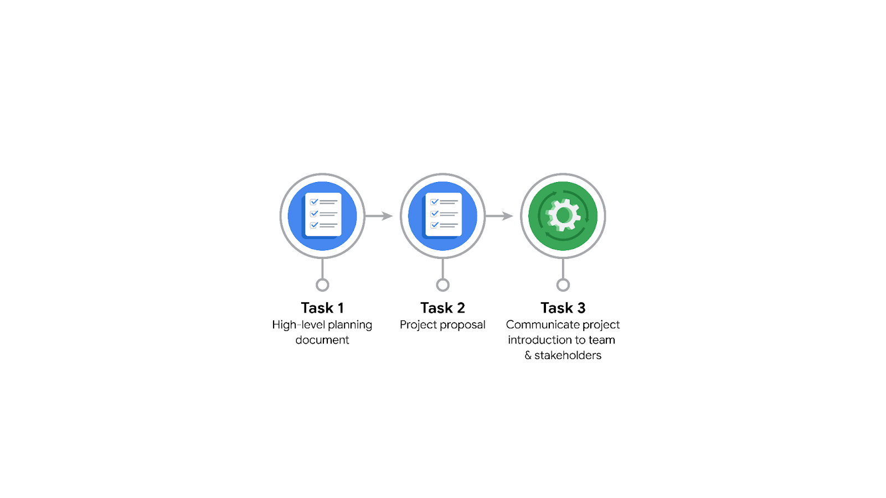

**Data Project Questions & Considerations**

**PACE: Plan Stage**

* Who is your audience for this project?

- The users of WAZE app

- The company management who is worried about the churn rates of users.

* What are you trying to solve or accomplish? And, what do you anticipate the impact of this work will be on the larger needs of the client?

- Trying to make the app more desirable, engaging and helpful so that users have a better navigation experience and continue using our service.

* What questions need to be asked or answered?

- Why are users not using our services anymore?. What keeps them from having the best UX? What are the ways we can adress these insufficiencies and discontent on the customer side?

* What resources are required to complete this project?

- Need for activity data and customer feedback, and significant events like updates or appearance of competitors.

- Data Engineers, Data Analyst, Data Stewards, Data Scientists, Management Team

- Reasonable Budget to pay the employees and account for needed software and computing power

* What are the deliverables that will need to be created over the course of this project?

- Manageable dataset + an overview of its contents (post EDA)

- Machine learning model that reviews and helps understand the behavior and activity of WAZE’s users.

- A report that collects the insights gained

- A plan for further action and how to use these insights to create impactful solutions

## 

## **THE PACE WORKFLOW**

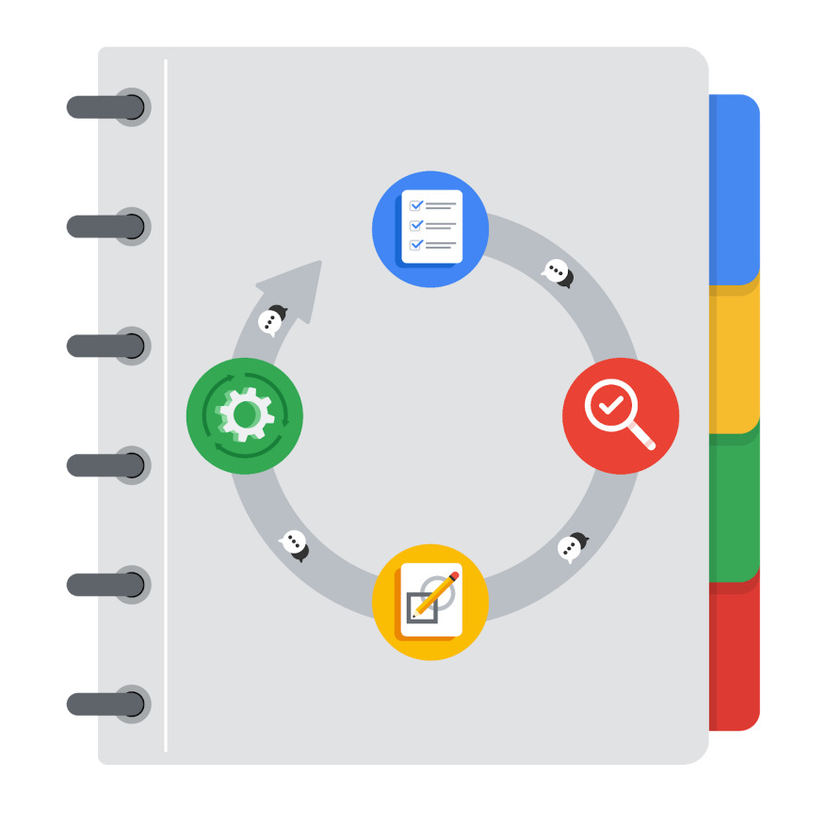

**[Alt-text: The PACE Workflow with the four stages in a circle: plan, analyze, construct, and execute.]**

You have been asked to demonstrate for the company's data team how you would use the PACE workflow to organize and classify tasks for the upcoming project. Select a PACE stage from the dropdown buttons. A few tasks involve more than one stage of the PACE workflow. Additionally, not every workplace scenario will require every task. Refer back to the Course 1 end-of-course portfolio project overview reading if you need more information about the tasks within the project.

### 

### **Project tasks**

Following are a group of tasks your company’s data team has determined need to be completed within this project. The data analysis manager has asked you to organize these tasks in preparation for the project proposal document. First, identify which stage of the PACE workflow each task would best fit under using the drop down menu. Next, give an explanation of why you selected the stage for each task. Review the following readings to help guide your selections and explanation: [The PACE stages](https://www.coursera.org/learn/foundations-of-data-science/supplement/4OtHr/the-pace-stages) and [Communicate objectives with a project proposal](https://www.coursera.org/learn/foundations-of-data-science/supplement/79Ysh/communicate-objectives-with-a-project-proposal). You will later reorder these tasks within a project proposal.

1. **Evaluating the model:** Execute

Why did you select this stage for this task?

- I selected construct because the model is not yet final and hence excecution is not yet a reasonable possibility

- After iteratively developing and updating the model, this task shifts toward the execute stage

1. **Conduct hypothesis testing:** Analyze **and** Construct

Why did you select these stages for this task?

- Hypothesis testing can happen in both the exploratory data analysis part (analyze) and in the stage where models are used to gain insights and support the discussion of hypothesis (construct)

1. **Begin exploring the data:** Analyze

Why did you select this stage for this task?

- This step involves enabling other colleagues to develop a model. It’s a preparation of the data that will lead to insights where the available data needs to be handled, cleaned or formatted.

1. **Data exploration and cleaning:** Plan **and** Analyze

Why did you select these stages for this task?

- This step involves enabling other colleagues to develop a model. It’s a preparation of the data that will lead to insights where the available data needs to be handled, cleaned or formatted. It’s the same as begin exploring the data just that it a process that occurs after intial exploration. This one is more in depth.

1. **Establish structure for project workflow (PACE):** Plan

Why did you select this stage for this task?

- This section is a crucial foundation. Everyone in the team needs a reference point which is possibly a document containing the expected workflow during this project.

1. **Communicate final insights with stakeholders:** Execute

Why did you select this stage for this task?

- At this final stage, meaningful insights and conclusions should have been gathered and they can now be shared with higher management to plan further action with the help of the insights to improve churn rates.

1. **Compute descriptive statistics:** Analyze

Why did you select this stage for this task?

- This step involves enabling other colleagues to develop a model. It’s a preparation of the data that will lead to insights where the available data needs to be handled, cleaned or formatted.

1. **Visualization building:** Analyze **and** Construct

Why did you select these stages for this task?

- Meaningful insights and conclusions should be gathered and the development of tools or ML models should be guided by these. Hence Analyze because it is part of understanding the date and it is foundational for proper development of ML models.

1. **Write a project proposal:** Plan

Why did you select this stage for this task?

- This section is a crucial foundation. Everyone in the team needs a reference point which is a document showing the goals and the subtasks of this project. It serves as planning but also as guidance throughout the whole project

1. **Build a regression model:** Analyze **and** Construct

Why did you select this stage for this task?

**- This is a process that involves constructing the tool (ML model) to later gain insights. No insights are extracted yet hence its part of the construct stage.**

1. **Compile summary information about the data:** Analyze

Why did you select this stage for this task?

- This step involves enabling other colleagues to develop a model. It preceed and follows the preparation of the data and makes it overseable how the dataset is composed and what it contains.

1. **Build machine learning model:** Construct

Why did you select this stage for this task?

**- This is a process that involves constructing the tool (ML model) to later gain insights. No insights are extracted yet hence its part of the construct stage.**